BLUE RIBBON: CREATIVE LINE DESIGN 2nd Place
Spider Chrysanthemums

2ND PLACE ---LINDA PORTER
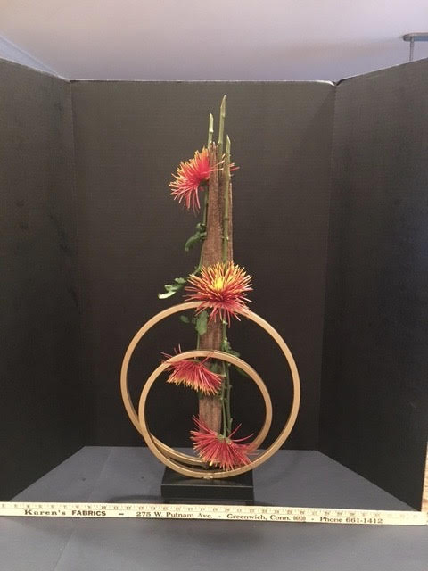

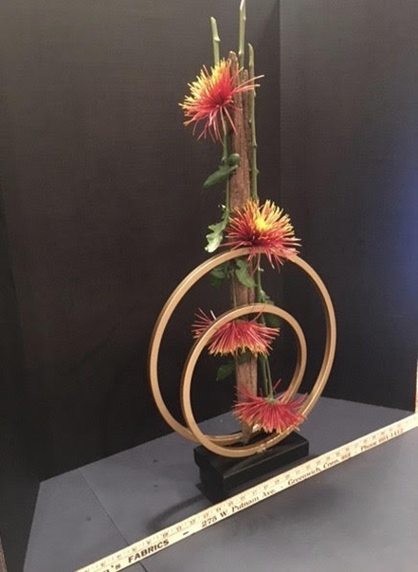

Conformance: +7 points -1 Not all materials identified. What is spiral?
Balance: Interrupted by use of spiral.
Contrast: Color and texture contrast created by mums and their stems.
Dominance: Spiral dominates Vertical Line.
Proportion: Proportion and scale appropriate for space used.
Rhythm: Interrupted by spiral.
Scale: Use of spiral hinders scale and proportion of design.
Selection of Components: Originality of components hinder effectiveness of design.
Organization of Components: Design divided by unique use of components.
Expression: The gift of the “circle of life.”
Distinction: Good
BLUE RIBBON: CREATIVE LINE DESIGN 3rd Place
Casablanca Lily, Split leaf rhododendron, black-painted pod, coil.
3rd PLACE----LUCY HUDOCK
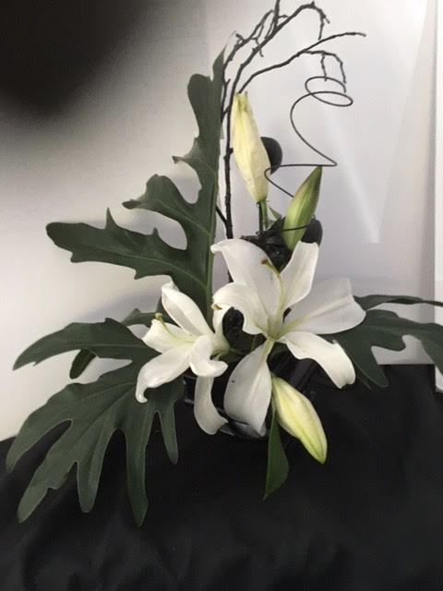
Conformance: -7 points Creative Line Mass…can’t see the line.
-1 Misidentified plant material: Split Monstera Leaf not rhody.
Balance: Asymmetrical visual balance created by color contrast.
Contrast: Pleasing color contrast created by leaf and lily.
Dominance: Lily dominates design.
Proportion: Design appears to relate to staging in this photo.
Rhythm: Some rhythm created by coil.
Scale: Size and scale relate to each other. Creative line not obvious.
Selection of Components: Components created a “Line Mass” not “Line.”
Organization of Components: Design too cluttered for a “Line.”
Expression: “Love and delight ….”
Distinction: Good
BLUE RIBBON: CREATIVE LINE DESIGN 1st Place
Chrysanthemums, hydrangea, winter berry, green and bronze leaves.

1st PLACE----MARTHA MARQUAND

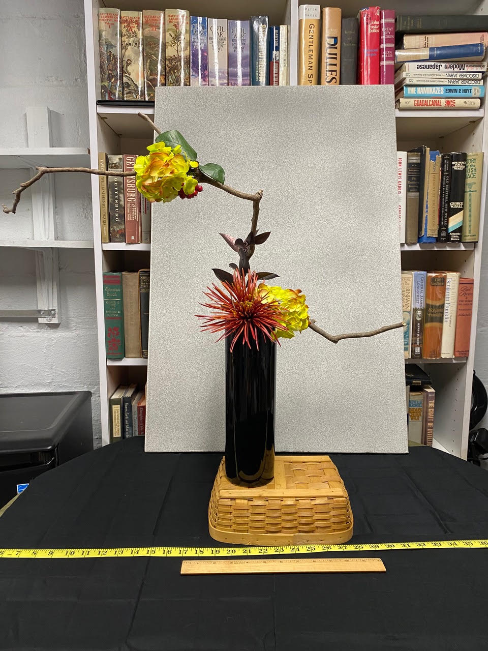
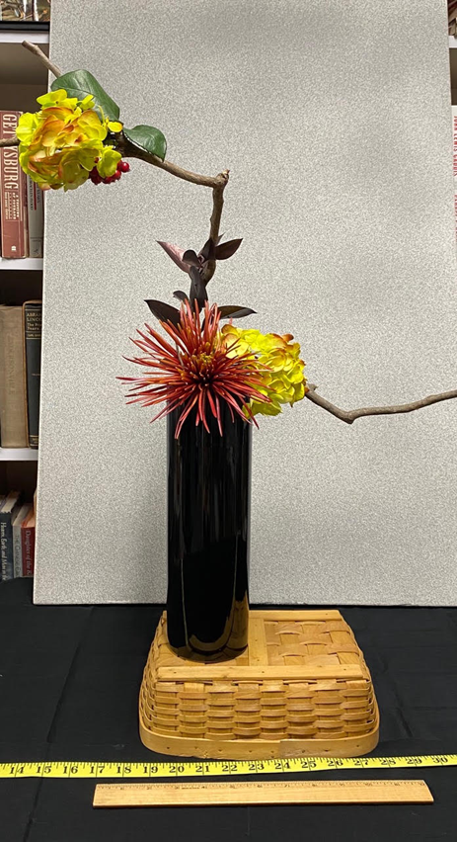
Conformance: + 7 points Creative Horizontal Zig Zag Line Design
Balance: Background position distorts design balance.
Contrast: Great color and floral texture contrast.
Dominance: Basket dominates design.
Proportion: Size and proportion of background improperly staged.
Rhythm: Exciting rhythm created by branch and floral placement.
Scale: Size and scale of basket does not relate to total design.
Selection of Components: Basket does not contribute to design.
Organization of Components: Unique zig zag design impaired by vertical background.
Expression: Exciting example of “’tis a gift to be free….”
Distinction: Good

