RGC NOVICE: TRADITIONAL LINE DESIGN
roses, branch, begonia leaves 3rd Place
3rd PLACE--=DEBBIE KRAUTHEIM
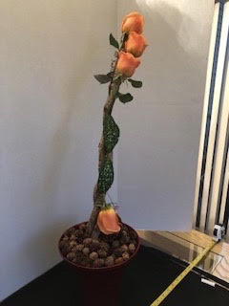
This is a “CREATIVE” Line Design Not a “TRADITIONAL.
See page 70-71 of the NGC FS Handbook for Traditional Line Design
V.A. Characteristics (1. Set pattern of geometric form; 2. Plant material used in naturalistic manner, radiating from one point. Little or “no” abstraction.; etc.
Conformance – minus 7 points. Vertical Line
Design Abstraction: Up-side-down Rose emerging from the base.
Balance: Weight of roses at top appears to cause design to lean.
Contrast: Good contrast between background and design.
Dominance: Roses at top dominate the design.
Proportion: Space used in front of background out of proportion.
Rhythm: Bold vertical line has little rhythm. Grouped roses at top eye stopper.
Scale: Size and scale of components relate to each other.
Selection of Components: Interesting
Organization of Components: Rose grouping top heavy, container a bit small.
Expression: Very creative
Distinction: Good technique. Craftsmanship at base a little off balance.

RRGC NOVICE TRADITIONAL LINE DESIGN
curly willow, chrysanthemums 2nd Place
2nd PLACE—ELLEN BRENNNAN-GALVIN
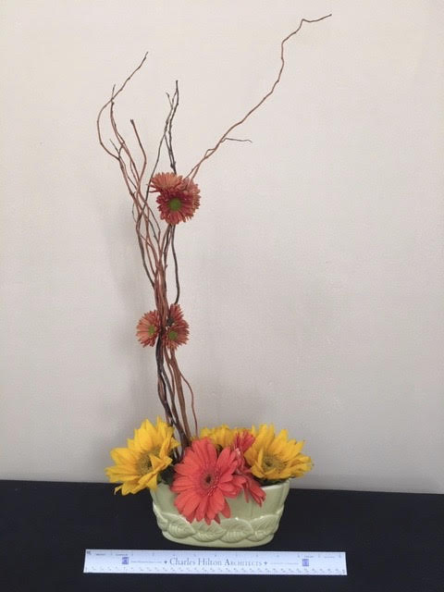
Conformance: 7 points. Geometric form: right angle. Gerber Daisy not named.
Balance: Asymmetrical balance anchored by Gerber’s emerging from container.
Contrast: Good color contrast between background and design.
Dominance: Gerber’s and white container dominate the design.
Proportion: Space used in front of background looks appropriate.
Rhythm: Curly willow creates rhythm. Movement interrupted by placement of mums.
Scale: Size and scale of components appear in balance with each other.
Selection of Components: White container dominates the design.
Organization of Components: Creative asymmetrical organization.
Expression: Very artistic movement created.
Distinction: Good technique and craftsmanship. Gerber’s seem a little messy.

1st PLACE—JULIE DIRAIMONDO
RGC NOVICE TRADITIONAL LINE DESIGN
Novice Participant 1: chrysanthemums, branch 1st Place
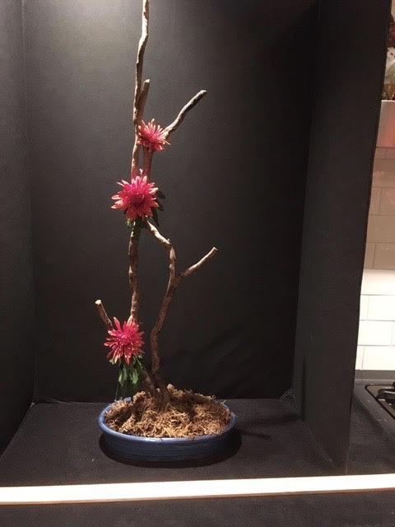
Conformance: 7 Points - Vertical Line
Balance: Branch composition balances the design.
Contrast: Good color contrast between mums and background.
Light creates drama by highlighting branches, mums and container.
Dominance: White line in front of design? Can’t figure out what that is?
Proportion: Space surrounding design looks in proportion to background.
Rhythm: Reflected light creates exciting rhythm carrying the eye throughout design.
Scale: Size and scale of components completely relate to each other.
Selection of Components: Excellent choice of components.
Organization of Components: Excellent creative organization of components.
Expression: Romantic oriental feel dramatized with lighting.
Distinction: Excellent Technique and Craftsmanship

