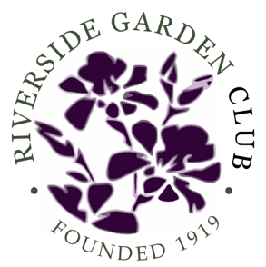 RIVERSIDE GARDEN CLUB
Riverside CT
Founded April 1919

Membership Information

Riverside Garden Club is a civic minded, diverse group of Gardeners, Conservationists, Floral Designers and Horticulture Enthusiasts, who share a commitment to Community beautification and Environmental Protection.

We have monthly club meetings which are held the fourth Tuesday of the month in September, October, November, January, February, March, April and May. The meetings, which start at 10:00 am, incorporate floral design, horticulture, refreshments, a short business meeting and a program or workshop on a variety of topics. This year we have migrated to virtual meetings. Recent programs include “How to make beautiful centerpieces for your home” by Cathy Ritch (see website for demonstration), a presentation by Martha Marchese, Red Bee Honey Beekeeper on how she became an “Accidental Beekeeper” and “How to make a beautiful Butterfly Garden” by Carrie Greenwald.

In early October, a small, standard flower show is held in conjunction with The Garden Club of Old Greenwich. Generally, the club has an evening Holiday Party in early December and an annual awards luncheon in early June. Along with civic projects around the community, we have two full or half day field trips and a few wine & cheese evenings throughout the year (a normal year that is).

To get more of a sense of the club, the floral design and horticulture exhibits, upcoming events, civic endeavors, those interested are encouraged to go to our website: https://www.riversidectgardenclub.org

To come to one of our events, email us at riversidectgardenclub@gmail.com,

