Connecticut is home to over 300 different species of bees! Squash bees are important and efficient pollinators of squashes and related plants, such as cucumbers and pumpkins. Carpenter bees are a common sight in summer, appearing like giant bumble bees with shiny black abdomens. Mason bees, such as orchard mason bees, are important pollinators of many fruiting trees.
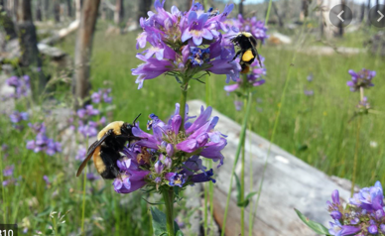
Bees are one of the most important groups of pollinators on the planet, and are responsible for the vast majority of insect-driven pollination. Bees are generally covered in fine hairs that can collect pollen, making them very effective at fertilizing the flowers they visit.
While some bees are social beings, like honey bees and bumble bees, most of the 300 Connecticut bee species are solitary, meaning that they do not form colonies. Female solitary bees lay eggs in cavities in the ground or in wood, and line those cavities with leaves and mud. Mining bees, digger bees, oil-collecting bees are all solitary, ground nesting bees.
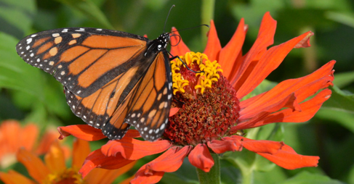
Butterflies and Moths: Although butterflies and moths do not provide the same amount of pollination services as bees, they are always great to see in your garden.
Flies are important and often overlooked pollinators. Many hover flies mimic bees in both appearance and behavior. Though they share the same black and yellow coloration, they do not sting. Pollinating flies are generally not covered in as much hair as bees, though they will still transfer pollen between plants from what sticks to their bodies as they forage.
Beetles: Pollination by beetles’ accounts for a small percentage of overall flower pollination. Nevertheless, beetles, ranging from scarab and long-horned beetles to checkered beetles and tumbling flower beetles, may transfer pollen between flowers. Magnolias, for example, are visited by many insects during their flowering period; however, it is the beetles that are present when pollen is plentiful.

